cOMPREHENSIVE cANCER cENTER

Website Design & Implementation

OPERATION MANUAL

University of michigan, nORTH cAMPUS rESEARCH cOMPLEX

CANCER CENTER INFORMATICS

**Revision I**

**Author: Jing Han**

Table of Contents

1. Introduction 1

Institution Overview 1

2. General Use 3

Account Associated 3

Viewing Contact Information 4

Content 6

Edit Content 9

4. System Core Functionalities 10

Tags 10

Views 11

Theming 13

Panel 18

5. Site Map 19

6. Drupal Functionalities Overview 20

7. System Module Applied 21

Core Functionality 21

Data Types 21

Prerequisites/Development Tools 22

8. User Types 23

Permission Control 23

Chapter

1

# 1. Introduction

The CCI website is built using the flexibility of Drupal, the website is intended to allow administrators to do more than dynamically interacting with the contents.

## Institution Overview

The Cancer Informatics Core of the University of Michigan Comprehensive Cancer Center (UMCCC) serves as a unified organizational structure to assist in the sharing, access, and analysis of data across information systems for translational, clinical and basic cancer research. This organizational structure allows for easier access to the available resources and domain expertise.

#### Mission

The mission of the Informatics Core is to support the informatics needs of both clinical and basic science investigators by providing the technological infrastructure and informatics/regulatory expertise to ensure the reliable and secure acquisition, storage, analysis, and application of biomedical data from both patients and biospecimens in order to promote the quality of peer-reviewed publications as well as translational medicine that will ultimately lead to novel discoveries and improved patient care.

#### Vision

The Informatics Core aims to provide effective, efficient and coordinated use of resources, a framework for developing cancer informatics infrastructure and tools, and transparent integration of data. As data-intensive research increases at the Cancer Center, the Informatics Core will continue to work towards expanding its capabilities and services in order to meet the growing demands of the Comprehensive Cancer Center core members and also establish the UMCCC as a national leader in the field of cancer informatics and its application to patient care.

The Cancer Informatics Core is designed as the central facility to support the informatic needs of Cancer Center researchers, allowing investigators to focus on their own work and have those with bioinformatics expertise address the myriad of informatics components that typical research is relied on. The Core addresses the following aspects and beyond:  
1. designing and maintenance of databases,   
2. development of novel bioinformatics tools,   
3. integration of disparate clinical and molecular data from multiple sources,   
4. purchasing, maintaining, and upgrading hardware and software,   
5. ensuring that data is secure and meets HIPAA-compliance standards,   
6. hiring and training skilled technical professionals, and   
7. assisting with data exploration, mining, and analysis.   
Thus, the Core will provide for a more effective, efficient and coordinated use of resources, a framework for developing cancer informatics infrastructure and tools, and transparent integration of data to support clinical, translational, and basic science research.

Chapter

2

# 2. General Use

## Account Associated

For security purpose, the login field is hidden from the website. In order to log in to manage the site, users will have to access through direct URL.

Currently, only administrators are granted with the right for creating accounts. Visitors with the login URL will NOT able to create an account.

Login

Type in the URL: <http://cci.sites.uofmhosting.net/user>, you will see the login page.

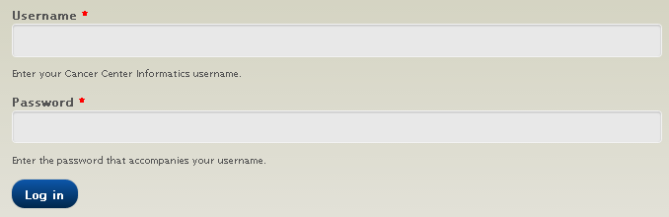

Create Account

1. Login into the site as administrator, you will see an administration menu displayed on top of the browser. Click on “people” 🡪 “add user” and fill out the form to create users.

To create a new user, you will need to provide their email, which should not be stored in the system already.



Note: created users can be either authenticated or administrator. The difference in rights between the two roles is specified in “people” 🡪 “permissions”. Generally speaking, authenticated users can modify and view certain relatively confidential content, but won’t be able to configure the website.

## Viewing Contact Information

On people page, a list of CCI employees is shown. Click on their name, the link will direct you to the profile information of this person.

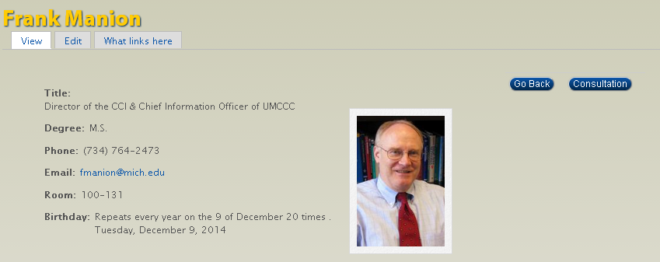

“Go back” lead you to return to previous page, while “consultation” button will direct you to the web form.

**Edit Contact Information**

To edit specific information of a contact, click on the “Edit” and a form will show up for editing.

To change the layout and order of information,

1. Go to [Structure]🡪[Panels] to edit. 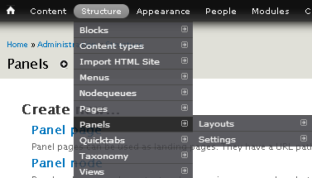
2. Go to [Node Template] Click on Edit on the right



1. Click on [Variants]🡪[Employees] or [In_Emp] to expand selection, 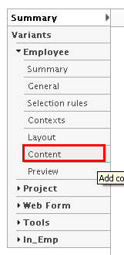
2. Click on “Content ” to configure what to display and what doesn’t

*Note

For more information, Please refer to Core Functionality Section.

The difference between [Employees] and [In_Emp] are the previous one set visibility for external visitors while [In_Emp] set the view for on-site users.

Chapter

3

## Content

**Content Type**

A total of five content types are created for the site, they are ARTICLE, BASIC PAGES, PEOPLE, SCHEDULE and WEBFORM.

**Add Content**

Hover over content and click on “add content” to select a type of content to add.

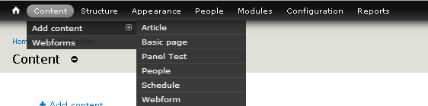

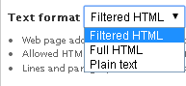**Content Features**:

* Drupal content can be displayed in three forms. Filtered HTML is content oriented, but have text editing effects enabled such as bullet point, indented text and so forth.
* 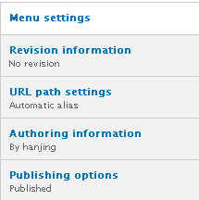Some additional configurable settings are displayed below. You may explore them on the site to play with these features. The settings used are Menu settings(Provide a menu link) are URL path settings (Generate automatic URL alias)

**Basic Pages**

All links appear at the navigation menu are basic pages. These are primarily used basic pages, some other webpages previously created are still saved in the site database, but are not linked anywhere from the current site.

Note:

* The basic page name of “Home” is “CCI Site”, the same as the title
* Basic Pages are a content type used for relative static web content, not the parent type for any other content types.



**Article**

All content published on basic pages are created in form of article. In CCI site ARTICLES are typically used for each project and tool.

**People**

PEOPLE type is created to record background information of employees in CCI. A general view of all PEOPLE is available of the website PEOPLE page.

Customized field under this type are:

|  |  |  |  |  |  |
| --- | --- | --- | --- | --- | --- |
| Person |  | |  | |  |
| Field | | Description / Example | | Type | Widget |
| CCI People | | First Name + (Middle Name) + Last Name | | Text |  |
| Order | | Used to help arranging the order of people listing on PEOPLE page. | | Float |  |
| Degree | | Possible Degrees can be "M.B.A", "M.S.", "M.D.", "M.C.A.", "B.B.A", "B.S." and "P.H.D" | | Text |  |
| Team | | N/A All individuals are under Cancer Informatics Team Category | | Tag Reference | Check Boxes |
| Title | | (display photo for search results and profile) | | Text |  |
| Profile | | Personal Picture | | Image | Check Boxes |
| Email | | * Attention to the email ending | | Email |  |
| Phone | | Recording work Station phone | | Phone Number |  |
| Experiences: | |  | | Long Text |  |
| Publications | |  | | Long Text |  |
| Room | |  | | Text |  |
| Cubicle | |  | | Text |  |
| Cell Phone | | Personal Phone | | Text |  |
| CCI Anniversary: | | Repeatable and is shown up on Calendar | | Date |  |
| Birthday | | Date |  |

* All input value can be changed in the future
* Except the name filed, all field can be left blank
* All fields can be renamed
* **Be very cautious with field deletion, as all content saved in the field will be lost together with the filed.**

**Schedule**

SCHEDULE type is used for activity arrangement. All activities created and saved will be marked on the calendar together with staff members’ anniversary and birthdays.

Customized field under this type are:

**Title**

**Duration**

**Date:** Allow repeat on weekly, monthly or yearly basis **Event Type:**

Holiday: National Holidays are already added to schedule

Meetings: Wait to be added

|  |  |  |  |
| --- | --- | --- | --- |
| Schedule |  |  |  |
| Field | Description / Example | Type | Widget |
| Title |  | Text |  |
| Body | Summary of event content | Long Text |  |
| Duration |  | Date | Select List |
| Date | Organization, Company, Startup Team | Date | Pop-up Calendar |
| Event Type | Holiday: National Holidays are already added to schedule  Meetings: Wait to be added | Term Reference | Select List |

**Web Form**

On Contact Us page, there is a Web form for site visitors to submit questions.

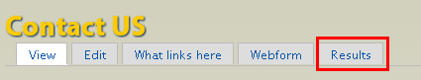

For site administrators, there will be a “Results” table, click on which could see all form submissions visitors made and there are export options, download all posts as text or excel format.

**Searching for Organizations**

Search Bar on the upper right of the site has enabled contextual based search of the site. Search functions would be able to find people, projects, tags and so forth.

* Note: The search may also reveal site contents that are published but not linked to the site.

## Edit Content

All Content Type can be easily edited by clicking on the “Edit” button right underneath the content title.

**HOME**

Slideshow-Modify in Template folder

Tab Switch- [Structure]🡪Quick Tab

Bottom Tools & Project 🡪Views🡪 Tools&Project

**ABOUT US**

View Calendar

No Content

**SERVICES**

HTML Page

**PROJECTS**

ViewProject

**TOOLS**

HTML Page

**PRICES**

Static Text Content

**PEOPLE**

View People

**CONTACT US**

Static Text Content

WebForm

Chapter

4

# 4. System Core Functionalities

The “icon key” at left was produced by using the Heading 8 style for the words “icon key” and the List Bullet 5 style for the text below—which uses a Wingdings symbol for the bullet character. To change the bullet symbol, click **Bullets and Numbering** on the **Format** menu. Click **Modify**, and then click the **Bullet** button. Select a new symbol, and then click **OK** twice.

To change the shading of the Icon 1 style, click **Borders and Shading** on the **Format** menu. Select a new shade or color, and then click **OK**.

## Tags

Taxonomy

Tags are given for both “Projects” and ”Tools” content. To access and modify Tags, go to [Structure] 🡪[Taxonomy] menu.

General Category: Projects/Tags

Specific Category: By Service Type

**Events**

Classify events by type: Holiday, Meeting and “other”. More types of event can be further added.

**Tags**

Different from its common application, tags here are used to group projects and tools by their feature.

Why need it: tags marked on each project and tool article are useful to generate views to sort individual items by category.

URL pattern: [site]/tags/[tags_name] (Spaces in terms are replaced by “-” dash)

List of terms include:

* Category Term

Each term corresponds to a sub category in tools:

* + Data Management, Molecular Data, Registry, Clinical Informatics
* Title Term
  + CORECT, Lab Checker, Pop Core, PubMed, Velos
* Type Term (!important -both projects and tools are created as “article” [Content Type], type terms are used to differentiate them):
  + Tool
  + Project

**Team**

For grouping people by teams they belong to. It is designed to be used in “people” [Content Type]. Classifications are referred from the former bioinformatics site. All settings here are flexible to change. List of terms include:

* Clinical Trials Office
* Cancer Informatics Team
* CaTissue Team
* Bioinformatics Team

Social Sharing page

## Views

**Calendar**:

**Display: View**

Three types of events are displayed:

* Scheduled events (content type: Schedule)

Sub types are:

* + Meeting
  + Holiday
  + Other
* Employees’ Birthday,
* Employees’ anniversary

Visibility: For now, calendar view is just configured to be visible towards authenticated and administrators. Only logged in user can

**Scheduled Events**: can be used for regular weekly meetings, and national holidays.

Tools

URL naming norm: All Tools Page can be retrieved by input the tool name in lower case, when there is a space in the name, replace by “-”. “/”slashes are not transformed in the URL naming process. For example, tool “Cancer Registry/i2b2” has the URL [site]/content/cancer-registryi2b2]

**Selection Rule**: all content with the tag “tools” are displayed in descending order by publishing time

Other Views

**Projects**

**Selection Rule**: all content with the tag “Projects” are displayed in descending order by publishing time

**Projects & Tools**

**Selection Rule**: all content with the tag “Projects” and “Tools” are displayed in descending order by publishing time

This section is displayed at the bottom of each page to promote

**Nodequene_1**

**Selection Rule**: Does the exact same thing as Projects & Tools, but have items listed in vertical order

**People**

**Selection Rule**: all content type of “people”

This section is displayed in table format on people page as an overview of all staff member.

Change theme

## Theming

To switch the theme from currently used theme.

1. Click on “Appearance” at the top of the menu bar



1. Select a theme and click on the “set default” link next to it

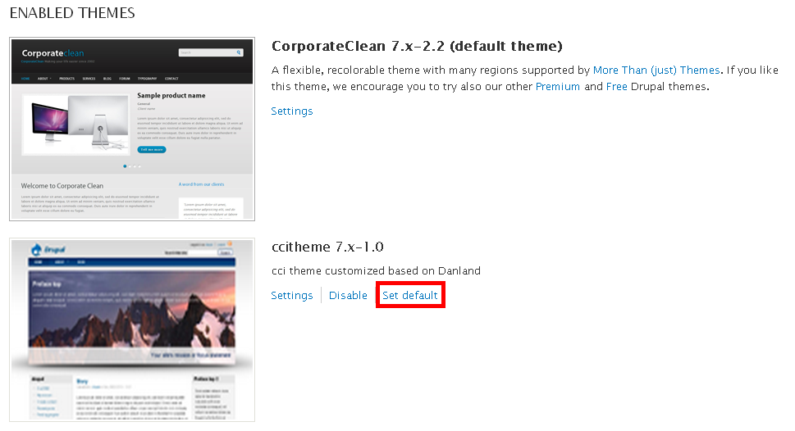

#### Themes developed:

Among all themes developed, **CCItheme** and **CorporateClean** are especially configured under Cancer Center Informatics concept and service, while **CFE theme1** and **Marinelli** just have been through slight modification to demonstrate capabilities of Drupal themes.

Theme Overview

#### Corporate Clean-Current

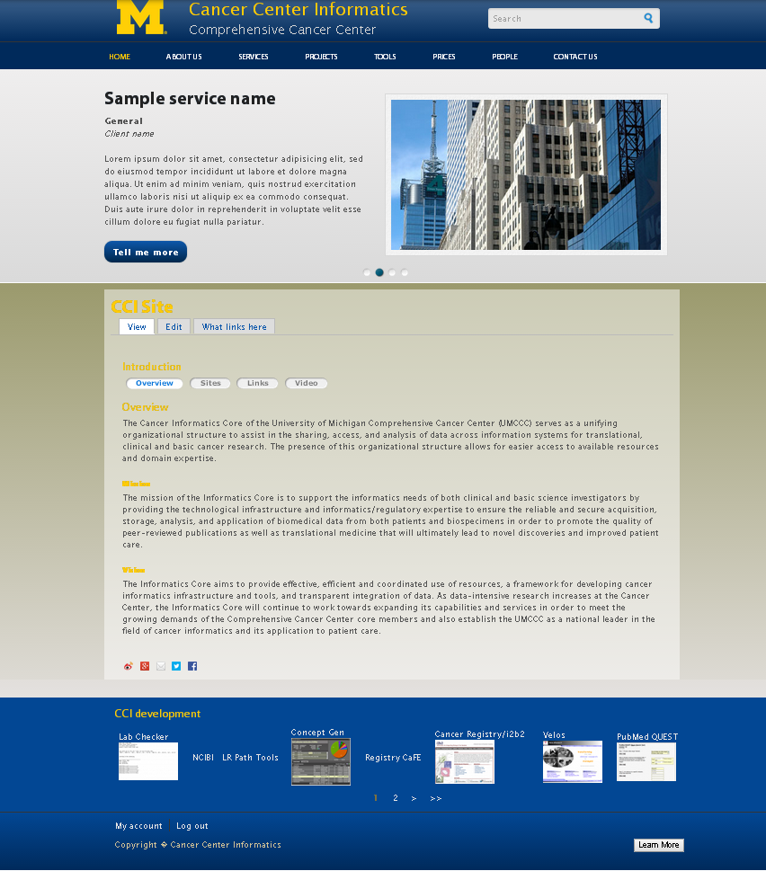  
**Color Schema**



#### ccitheme

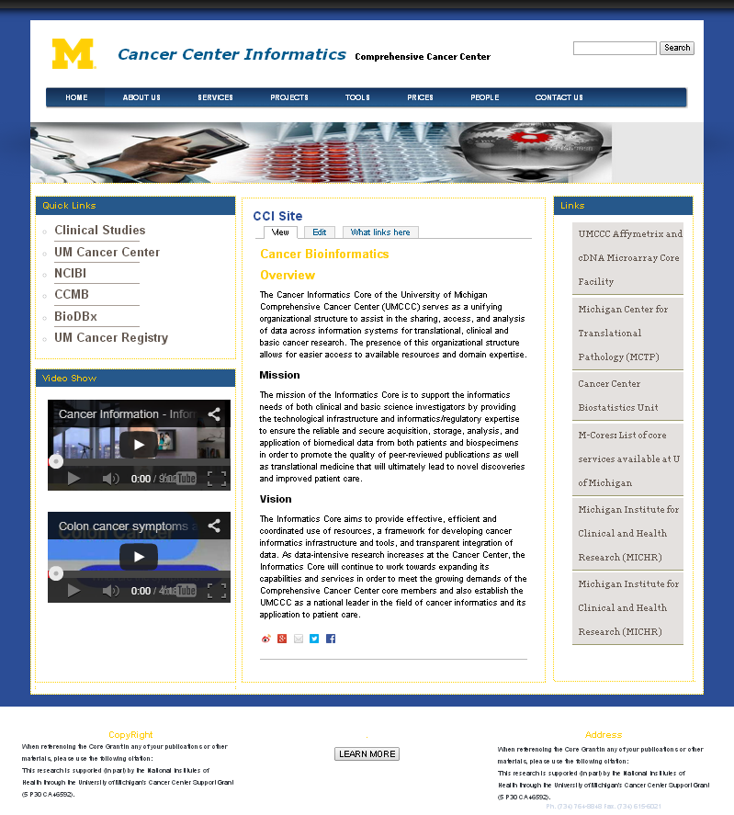

**Color Schema** 

#### danland

#### 

#### Marinelli

#### 

Current Layout

Refer to the general use section for customizing block

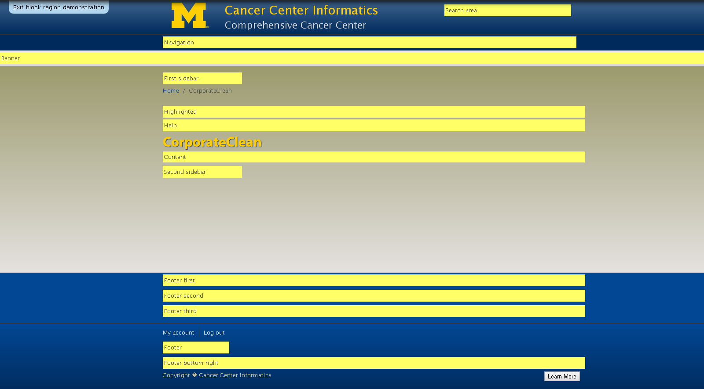

## Panel

The only panel used for now is Node Template, which appears at the first row of the panel page. Under this node, multiple variants are configured to serve different types of content.

**Project**

**Web Form**

**Tools**

**Employees**

**In_Emp**

Employees

Employee Panel is configured for visitors who don’t have account on the website.

**Selection Rules**:

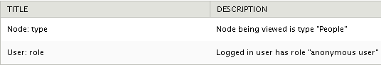

In Emp

In Emp is configured for people with an account in the right and reveal more information about the employees, such as birthday, work cubic and so forth.

**Selection Rules:**

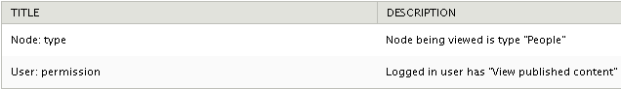

Chapter

5

# 5. Site Map

Here is an overview of the whole CCI website. The picture below shows relationship between site elements and their subordinate relationship.

Chapter

6

# 6. Drupal Functionalities Overview

Panels can organize page content

Views can display in form of page or Blocks

Block can show on Page and Panels

Quick Tab integrate several Views in one Block

Theme Layout Can be changed in Blocks

Theme Style must be configured in Theme Code Package

Chapter

7

# 7. System Module Applied

## Core Functionality

Administrator Tool

**Administration Menu** – Creating user friendly drop down menu for administration bar

**Administration Tool Bar Style** – Should be enabled together with the administration menu

**Chaos Tools** – Basic tools supporting fundamental site features

Panels

**Panel Nodes** - Create nodes divided into areas with certain content in each area

**Panels** - Core Panels functionality

**Page Manager** – Prerequisite for Panels to be working

Relation

**Relation** - Allows relationships between items

**Relation Endpoints Field** - Adds field for use by Relation module

**Relation UI** - Adds an interface for managing relationships

Search

**Database Search** - Implementation of Search API using database tables for indexing

**Search API** - Adds an API for modules with search capabilities

**Search Views** - Integrates searches and views

Sharing

**ShareThis** – Share the website to social media

## Data Types

Date/Time

**Calendar** - Allows display of dates (for events) as a calendar

**Date** - Add date/time fields

**Date API** - Allows other modules to use dates

**Date Popup** - Allows popup calendars and time widgets for selecting dates and times

**Date Views** - Integrates dates with views

Fields

**Email** - Add email fields

**Phone** - Adds a phone field

## Prerequisites/Development Tools

Chaos Tools

**Chaos Tools** - Library used by many modules

**Page Manager** - UI and API for page management.

**Stylizer** - Create styles

**Views Content Panes** - Allows using views content in features using Chaos Tools

Development

**Devel** - A collection of tools for developers

Features

**QuickTabs** – Content with Tabs and other Display Style

Theme

**ThemeKey** –Map themes to Drupal path and object properties

Rules

**Rules** - Adds automated reactions to events

**Rules Scheduler** - Allows scheduling of Rules executions

**Rules UI** - Adds administrator interface for Rules

Views

**Views** - Create customized lists and queries from your database.

**Views Aggregator Plus** - A Views plugin that operates on the results *after* the database query has run, thus offering aggregation functions not otherwise possible.

**Views Bulk Operations** - Provides a way of selecting multiple rows and applying operations to them.

**Views Export XLS** - Plugin to export views to XLS

**Views UI** - Administrative interface to views. Without this module, you cannot create or edit your views.

Other

**Menu Block** - Allows creating blocks containing menus

**Pathauto** - Allows modules to create aliases for content they manage

**Token -** Adds an interface for Token API and some missing tokens **Tipsy Tooltips** – Hover over Effect

**GMap** – Show Entity locations with Google Map

**GMap Location** - Display location Module information on Google Maps

**Location** - Associate a geographic location with content and users

**Node Locations** – Associate location with nodes

**User Locations** – Associate Location with user

**Wysiwyg** – Edit content with client side editors

**Superfish** – jQuery Plugin for dropdown menus

**XML sitemap** – Create sitemap so the site is easier for plugin to be found

* Note: Modules not mentioned in the document are free to be disabled or deleted from site.

Chapter

8

# 8. User Types

The mission of the Center for Entrepreneurship is to support entrepreneurial-minded UM students and alumni in creating successful ventures that have a positive impact on society. The CFE accomplishes this through several avenues of support. The center recruits UM alumni and other members of the Michigan entrepreneurial community as mentors who can provide advice grounded in experience. Through the Program in Entrepreneurship certification, the CFE provides academic programming that gives students structured frameworks for understanding successful startups.

Admin:

Site administrator should be able to make all configurations over the site and grant user permissions

User:

Site users should be CCI employees, having account to the site, can view and edit content but does not have manipulation right over the site. Considered as “Authenticated” users in Drupal

Visitor:

Site visitors who needs to learn information from the site. They usually don’t have account over the site.

For more information on user personas and goals, see the Appendix.

## Permission Control

N/A

Appendix –Website Design

